24.77: a) 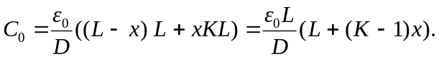
b) 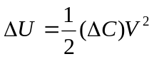where 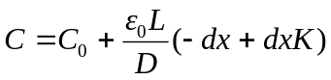
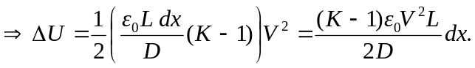
c) If the charge is kept constant on the plates, then:
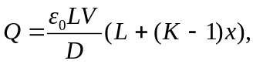and 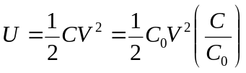
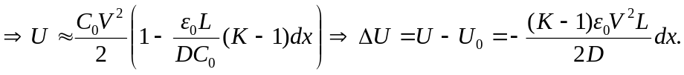
d) Since 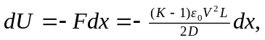 then the force is in the opposite direction to the motion 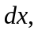meaning that the slab feels a force pushing it out.

